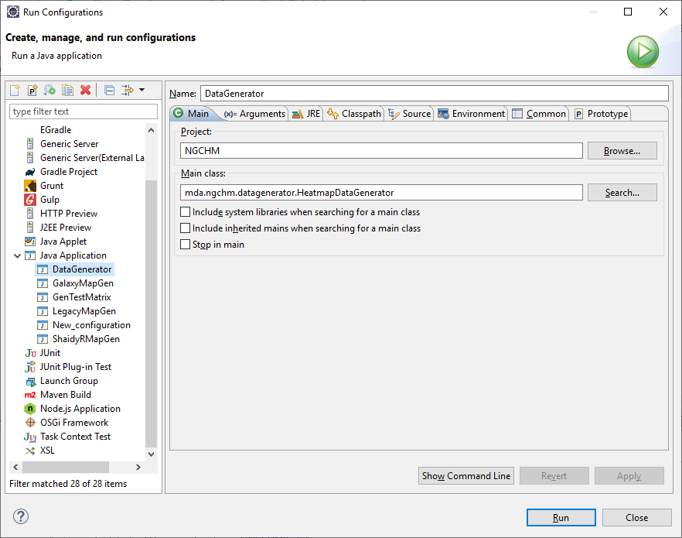

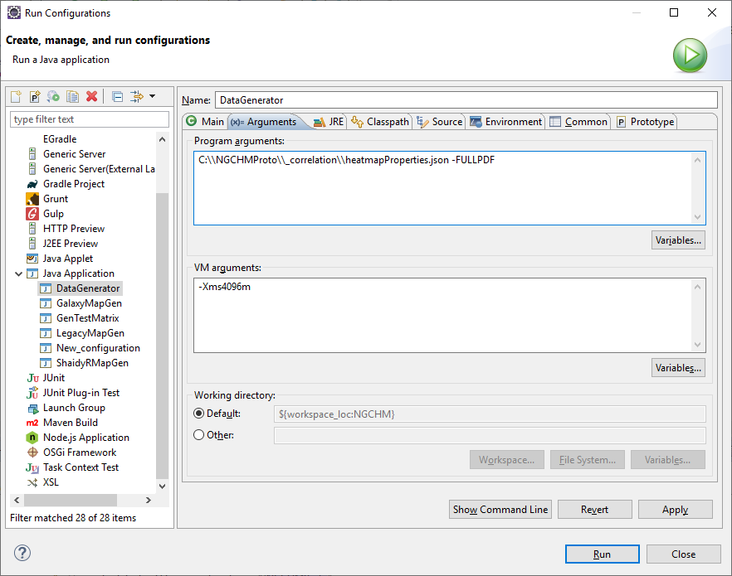

Add the above program arguments:

1. Directory to find the map’s heatmapProperties.json file
2. -FULLPDF to generate the full pdf.
3. -NGCHM is optional. I just have it in my current configuration

THERE ARE NO RELEVANT SETTINGS IN THE OTHER TABS